


iFYP
Lab Manual # 3 RISK V Procedures

NAME: Abdul Hadi Afzal
DATE:15 June 2025

NUST Chip Design Centre (NCDC), Islamabad, Pakistan
Copyrights ©, NUST Chip Design Centre (NCDC). All Rights Reserved. This document is prepared by NCDC and is for intended recipients only. It is not allowed to copy, modify, distribute or share, in part or full, without the consent of NCDC officials.

Revision History
Revision Number | Revision Date | Revision By | Nature of Revision | Approved By
1.0 | 04/03/2024 | Hira Sohail,  Muhammad Bilal | Complete manual | Dr. Waqar
1.1 | 21/05/2024 | Ali Aqdas | Additional Tasks | Dr. Waqar

Contents
Objectives 2
Tools 3
A Quick Summary 3
Example 1 – If-ElseIf-Else Statement 3
Example 2 – While Loop I 4
Example 3 – For Loop I 4
Lab Task 1: Find The Greatest Common Divisor 5
6
Lab Task 2: Bubble Sort 6
Lab Task 3: Quick Sort 8

Objectives
The objectives of this lab are to:
- Understand basic programs in assembly language covering following o Branches o Loops o
Recursion
s
- Find the greatest common divisor in assembly language
- Perform sorting using assembly language

Tools

- Venus

A Quick Summary

Example 1 – If-ElseIf-Else Statement
_start:
andi | t0, t0, | 0 | # clear | register | t0
andi | t1, t1, | 0 | # clear | register | t1
andi | t2, t2, | 0 | # clear | register | t2
andi | t3, t3, | 0 | # clear | register | t3
andi | t4, t4, | 0 | # clear | register | t4
andi | t5, t5, | 0 | # clear | register | t5
li t0, 2 |  |  | # t0 = 2
li t3, -2 # t3 = -2 slt t1, t0, zero # t1 = t0 < 0 ? 1 |  |  |  |  | : 0
beq t1, zero, ElseIf # go to ElseIf if t1 = 0
j EndIf # end If statement

ElseIf:
sgt t4, t3, zero # t4 = t3 > 0 ? 1 : 0
beq t4, zero, Else # go to Else if t4 = 0 j EndIf # end Else statement
Else:
seqz t5, t4, zero # t5 = t4 == 0 ? 1 : 0
EndIf:
j EndIf # end If-ElseIf-Else statement

Example 2 – While Loop I
_start: andi t0, | t0, | 0 |  | clear register t0
andi t1, | t1, | 0 |  | clear register t1
andi t2, | t2, | 0 |  | clear register t2
li t1, 100 |  |  |  | t1 = 100
loop:
add t2, t2, t |  | 0 | # t2 = | t2 + t0
addi t0, t0, |  | 1 | # ++t0
blt t0, t1, loop |  |  | # iterate if t0 < t1
end:
j end # end of While loop

Example 3 – For Loop I
_start:
andi t0, | t0, | 0 |  |  | # | clear register t0
andi t1, | t1, | 0 |  |  | # | clear regi | ster t1
loop:
andi t2, | t2, | 0 | # | clea | r t2 before |  | starting the loop
add t1, t1, t |  | 0 |  |  | # | t1 = t1 + | t0
addi t0, t0, |  | 1 |  |  | # | ++t0
slti t2, t0, 100 |  |  |  |  | # | t2 = t0 < | 100 | ? 1 : 0
bne t2, zero, |  | loop |  |  | # | go to loop if |  | t2 != 0
end:
j end |  |  |  | # |  | end of For loop

Lab Task 1: Find The Greatest Common Divisor

Code:
.data
msg: .asciiz "GCD is: "
newline: .asciiz "\n"

a_val: .word 24 # First number
b_val: .word 18 # Second number

.text
.globl _start

_start:
# Load a into t1
la t0, a_val
lw t1, 0(t0)

# Load b into t2
la t0, b_val
lw t2, 0(t0)

gcd_loop:
beqz t2, done # if b == 0, done
rem t3, t1, t2 # t3 = a % b
mv t1, t2 # a = b
mv t2, t3 # b = a % b
j gcd_loop

done:
# t1 now holds the GCD
la a0, msg
jal print_str

mv a0, t1
jal print_digit

la a0, newline
jal print_str

j stop
stop:
j stop

# ===== Utility: Print null-terminated string at address a0 =====
print_str:
mv t4, a0 # t4 = pointer to string
str_loop:
lb t5, 0(t4) # Load byte
beqz t5, str_ret # If byte is 0 (null), end
li a0, 11 # syscall: print char
mv a1, t5
ecall
addi t4, t4, 1 # move to next char
j str_loop

str_ret:
jr ra

# ===== Utility: Print single digit in a0 =====
print_digit:
li t6, '0'
add t5, a0, t6 # Convert number to ASCII
li a0, 11
mv a1, t5
ecall
jr ra
Output:

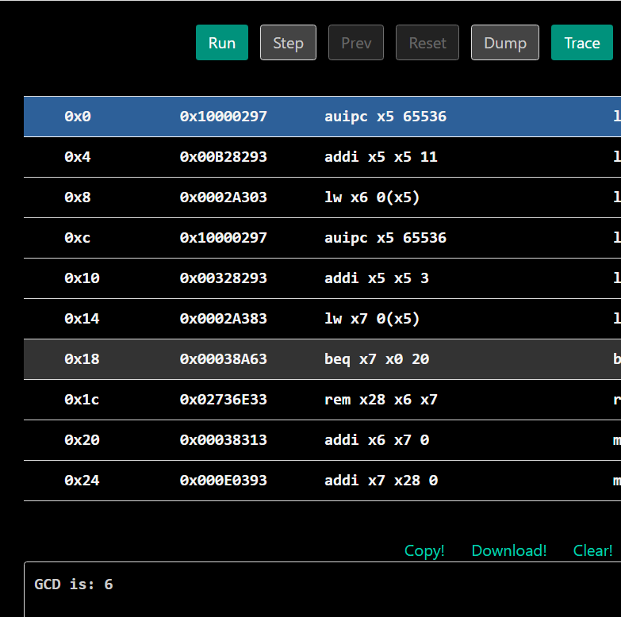

Lab Task 2: Bubble Sort

CODE:

.data
array: .word 12, 5, 8, 1, 19, 7, 3, 15, 2, 10, 6, 4
n: .word 12

.text
.globl main

main:
la t0, n
lw t1, 0(t0) # t1 = n

la t2, array # t2 = base address of array

li t3, 0 # t3 = i

outer_loop:
blt t3, t1, outer_continue
j print_array # done sorting

outer_continue:
li t4, 0 # t4 = j

sub t5, t1, t3 # t5 = n - i
addi t5, t5, -1 # t5 = n - i - 1

inner_loop:
blt t4, t5, inner_continue
addi t3, t3, 1 # i++
j outer_loop

inner_continue:
slli t6, t4, 2 # t6 = j * 4
add a0, t2, t6 # a0 = &array[j]
lw a1, 0(a0) # a1 = array[j]

addi t6, t6, 4
add a2, t2, t6 # a2 = &array[j+1]
lw a3, 0(a2) # a3 = array[j+1]

ble a1, a3, no_swap

# Swap array[j] and array[j+1]
sw a3, 0(a0)
sw a1, 0(a2)

no_swap:
addi t4, t4, 1
j inner_loop

print_array:
li t3, 0 # i = 0

print_loop:
blt t3, t1, print_continue
j done

print_continue:
slli t4, t3, 2
add t5, t2, t4
lw a1, 0(t5)

li a0, 1 # syscall print int
ecall

li a0, 11 # syscall print char
li a1, 32 # space
ecall

addi t3, t3, 1
j print_loop

done:
li a0, 10 # syscall exit
ecall
OUTPUT:
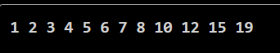

Lab Task 3: Quick Sort

CODE:
.data
array: .word -1, 22, 8, 35, 5, 4, 11, 2, 1, 78
array_size: .word 10

.text
.globl main

main:
la s0, array # s0 = base address of array (never changed)
li a0, 0 # a0 = low index
li a1, 9 # a1 = high index (n - 1)
jal quicksort # sort array from 0 to 9

jal print_array # print sorted array

li a0, 10 # syscall: exit
li a1, 0
ecall

# -----------------------------
# void quicksort(int low, int high)
# a0 = low, a1 = high
# -----------------------------
quicksort:
addi sp, sp, -16 # allocate stack space (4 bytes * 4)
sw ra, 12(sp) # save ra at sp+12
sw s1, 8(sp) # save s1 at sp+8
sw s2, 4(sp) # save s2 at sp+4

bge a0, a1, qs_return

mv s1, a0
mv s2, a1
jal partition

mv a0, s1
mv a1, a2
addi a1, a1, -1
jal quicksort

mv a0, a2
addi a0, a0, 1
mv a1, s2
jal quicksort

qs_return:
lw ra, 12(sp) # restore ra
lw s1, 8(sp) # restore s1
lw s2, 4(sp) # restore s2
addi sp, sp, 16 # restore stack pointer
ret

# -----------------------------
# int partition(int low, int high)
# returns pivot index in a2
# -----------------------------
partition:
slli t0, a1, 2
add t0, s0, t0
lw t1, 0(t0) # t1 = pivot = array[high]

addi t2, a0, -1 # t2 = i = low - 1
mv t3, a0 # t3 = j = low

partition_loop:
bge t3, a1, partition_done

slli t4, t3, 2
add t5, s0, t4
lw t6, 0(t5) # t6 = array[j]

ble t6, t1, do_swap

skip_swap:
addi t3, t3, 1
j partition_loop

do_swap:
addi t2, t2, 1
slli t4, t2, 2
add t4, s0, t4

lw t6, 0(t5) # t6 = array[j]
lw t5, 0(t4) # t5 = array[i]
sw t6, 0(t4)

slli t6, t3, 2
add t6, s0, t6
sw t5, 0(t6)

j skip_swap

partition_done:
addi t2, t2, 1
slli t4, t2, 2
add t4, s0, t4

slli t5, a1, 2
add t5, s0, t5
lw t6, 0(t5)
lw t5, 0(t4)
sw t6, 0(t4)

slli t6, a1, 2
add t6, s0, t6
sw t5, 0(t6)

mv a2, t2 # return pivot index
ret

# -----------------------------
# void print_array()
# -----------------------------
print_array:
li t0, 0 # index = 0

print_loop:
li t2, 10 # array size
bge t0, t2, done_print

slli t3, t0, 2
add t4, s0, t3
lw a1, 0(t4) # a1 = array[i]
li a0, 1 # syscall: print_int
ecall

li a0, 11 # syscall: print_char
li a1, 32 # space
ecall

addi t0, t0, 1
j print_loop

done_print:
li a0, 11 # syscall: print_char
li a1, 10 # newline
ecall
ret
OUTPUT:
